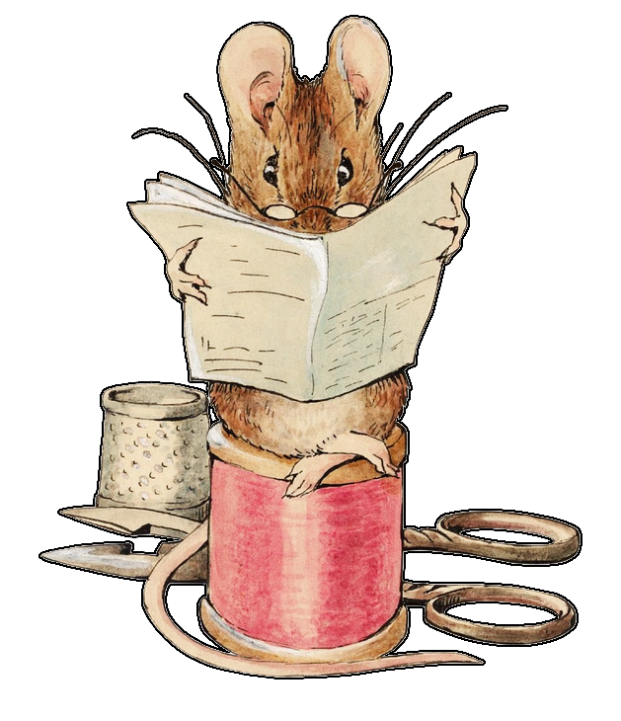
The Sophisticated Whisker
by Senator Bix (licensed CC-BY 4.0.)
Though she needs no introduction,
art by Beatrix Potter, from the public domain.
A Mouse Hotel Adventure
So you're little mouse people with a little hotel, and I'm going to ask you the question that is so rarely asked, what makes your mouse hotel special?
What's it like?
- Is it in an old stump on a forest path?
- Is it hidden in the corner of a tavern?
- Is it up high in an old squirrel burrow?
- Is it a little hole-in-the-wall in an ally by the market square?
- Is it cozy? Boisterous? Refined?
- What does each player bring to the table for this little endeavor? What’s your mouse good at?
The NPC Cast
- Quentin, a fox that loves to gossip.
- Barnaby, a swift shrew that runs a little repair shop.
- Lydia, a porcupine that loves to make trades.
- Taylor, a barn swallow with stories of far away lands.
- Horace, a vole that is just a good NPC to have around for anything you realize you might need an NPC for.
Notes:
________________________________________________________________
________________________________________________________________
________________________________________________________________
_______________________________________________________________
Our Adventurous Year
Summer: The world is busy and alive and wild and nervous.
- You're just staring out. You need to get word of mouth out there!
- Maybe the players wow a very particular guest. Taylor’s opinion is quite well regarded far and wide.
- Maybe some NPCs have ideas for how they could help?
- By the end of the summer, things are going well at The Sophisticated Whisker.
________________________________________________________________
________________________________________________________________
________________________________________________________________
________________________________________________________________
Autumn: In which Doris gets her oats.
- A wagon has gone astray and damaged your hotel! What's broken? How can it be fixed? Are walls cracked? Has a branch fallen? And what’s the deal with that horse?
- Maybe the repair is drawing unwanted attention from people that would frown upon such enterprising mice. Do you hide? Do you distract them?
- Maybe there is a cat. I don't know how cozy the threat of being eaten is, but you know your players. What will they do to deter this threat?
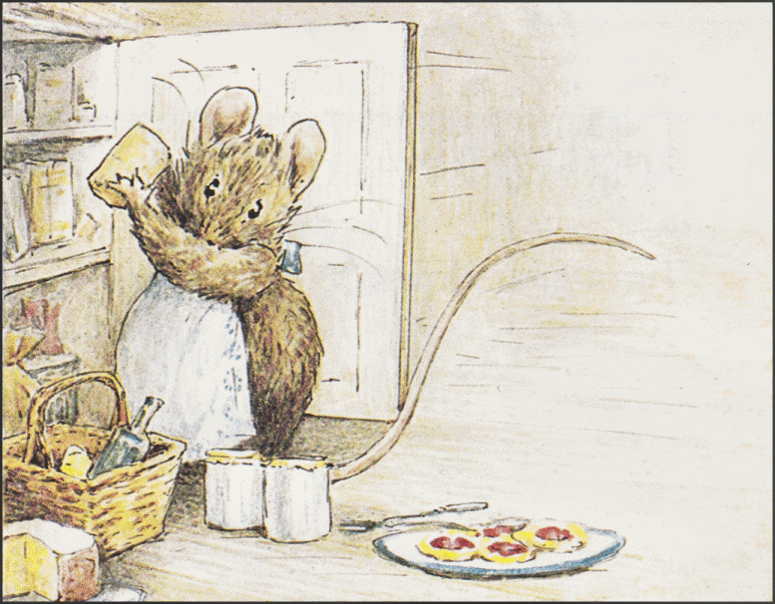
________________________________
________________________________
________________________________
________________________________
________________________________
________________________________
Winter: Even in hard times, we can find islands of joy on which to rest.
- A nearby river freezes over and you can travel across and see old friends. Maybe they are at one of the hotels you didn't chose at the start of the adventure. Maybe you help them with a problem they’re having?
- A famous playwright has cast you in a play! What's it about? Are you excited? Nervous? Hesitant? Maybe you've got to act out a little scene? Congratulations, you’ve done a TTRPG Inception.
- Maybe the players work together with the NPCs and stone soup their way to a feast. I wonder which NPC will be the most reluctant to help?
________________________________________________________________
________________________________________________________________
________________________________________________________________
________________________________________________________________
Spring: The most read-the-room of the seasons.
- Maybe the game's feeling done? Well then the players feel the sun start to knock some of the chill off the days and they know you've made it through the winter. You could just talk about your favorite parts of the year, maybe speculate on what might come next, and bring the game to a close.
- Maybe your players need a final boss. Bring back one of the adversaries from the autumn. It could be the same one, back to increase the stakes, or a new one to catch them unsuspectingly. Maybe an owl shows up?
- And finally, maybe Barnaby challenges you to a footrace? Gregarious boasting ensues. Perhaps a wager? I hear he'd be willing to put a pocket watch he just fixed on the line. Can you imagine it, our little hotel having a real gold pocket watch. It's hard to believe it's only been a year.

And that's it. Thank you for reading this adventure.
I hope it sounded like fun.
- Bix
Bonus Entire TTRPG System
This adventure can be played using any system, but here’s one so you have everything you need.
Players have 4 stats: Strong, Fast, Smarts, & Charm. You have 12 points to assign between them, and no stat can be lower than 1 or higher than 5.
If there is a challenge, roll a d6. You succeed if your roll is the same or lower than the appropriate stat. So if you were trying to sneak around you might compare your roll against your Fast. To lift a heavy branch you might roll against your Strong. If a player has an advantage in the situation, then roll twice and take the lower roll. If a player has a disadvantage, then do the same but take the higher number.
Damage can temporarily reduce stats. Any stat can be reduced. Maybe a scathing insult deducts from your Charm. Maybe hurting your leg takes away from Fast? If Strong reaches 0, you're incapacitated. A rest can bring those stats back. Players don’t have a ton of points, so maybe just take away one at a time.
That's the system. Although it’s short, it should cover a lot of ground. It’s borrowing from Into the Odd style game systems, but uses d6, the coziest of
all dice.
□
Your Mice:
Name | Strong | Fast | Smarts | Charm | Notes

